Lab 5 Tasks - DFS and Tree Traversals

# Task 1: DFS using Stack & Node

This program demonstrates Depth First Search (DFS) using an explicit stack and a node-based graph.

Steps:  
1. Define a Node class representing a graph node.  
2. Use a stack to explore nodes in depth-first order.  
3. Mark visited nodes to avoid repetition.

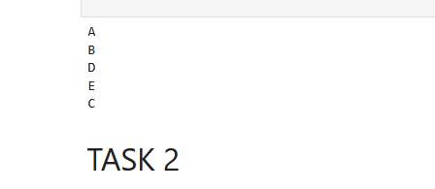

# Task 2: Inorder, Preorder, Postorder Traversals (DFS)

These are three types of Depth First Search (DFS) traversals for binary trees.

1. Inorder Traversal (SEQUENCE Left, Root, Right):  
 Visits the left subtree, then the root, then the right subtree.  
2. Preorder Traversal (SEQUENCE Root, Left, Right):  
 Visits the root, then the left subtree, then the right subtree.  
3. Postorder Traversal (SEQUENCE Left, Right, Root):  
 Visits the left subtree, then the right, then the root.

